D.K.T.E. Society’s Textile and Engineering Institute, Ichalkaranji.
Department of Computer Science and Engineering
2016-2017

A Software Requirement Specification for
“Dynamic Query Form For
Database Queries”

Under The Guidance Of
Prof. K. S. Kadam

Submitted By:
- Aishwarya Jain 13CMPN15
- Viraj Bharat Patil 13CMPN44
- Aishwarya Rahul Shah 13CMPM52
- Vaibhav Upadhyay 13CMPN59
- Rahul Bhat 08CMPN

Prof. K. S. Kadam Prof.Dr.D.V.Kodavade
[Project Guide] [Head of Department]

Department of Computer Science and Engineering
D.K.T.E. Society’s Textile and Engineering Institute, Ichalkaranji.

CERTIFICATE
It is here by certified that the project entitled “Dynamic Query Form for Database Queries
” has been successful completed in partial fulfilment of B.E. Computer Science and Engineering Part 1/November 2015 examination as per the requirement of Shivaji University, Kolhapur.To the best of our knowledge and belief, the matter included in it is their genuine work.

Submitted By:
- Aishwarya Jain 13CMPN15
- Viraj Bharat Patil 13CMPN44
- Aishwarya Rahul Shah 13CMPM52
- Vaibhav Upadhyay 13CMPN59
- Rahul Bhat 08CMPN

Prof. K. S. Kadam Prof.Dr.D.V.Kodavade
[Project Guide] [Head of Department]

INDEX
- INTRODUCTION Page no
  - Problem Description, Purpose 01
  - Scope 01

- OVERALL DESCRIPTION 02
  - Product perspective 02
  - Product functions 03

- SPECIFIC REQUIREMENTS 04
  - External interfaces 04
  - Functional Requirements 04
  - Performance requirements 04
  - Design constraints 04
  - Logical database requirements 04
  - Software system attributes 04

- SOFTWARE DESIGN DOCUMENT 05
  - Structural Design 05
  - Data Design 05
  - Behavioural Design 06
  - Environment Design 10

- TESTING, COSTING AND MEMBERS 11
- REFERENCES 12

1. INTRODUCTION
1.1 Problem Description:
Modern scientific databases and web databases maintain large and heterogeneous data. These real-world databases contain over hundreds or even thousands of relations and attributes. Traditional predefined query forms are not able to satisfy various ad-hoc queries from users on those databases. This paper proposes DQF, a novel database query form interface, which is
able to dynamically generate query forms. The essence of DQF is to capture user’s preference and rank query form components, assisting him/her to make decisions. The generation of a query form is an iterative process and is guided by the user. At each iteration, the system automatically generates ranking lists of form components and the user then adds the desired form components into the query form. The ranking of form components is based on the captured user preference. A user can also fill the query form and submit queries to view the query result at each iteration. In this way, a query form could be dynamically renewed till the user satisfies with the query
results.
Purpose:
How to let non-expert users make use of the relational database is a challenging topic. A lot of research works focus on database interfaces which assist users to query the relational database without SQL. We propose a dynamic query form system which generates the query forms according to the user’s desire at run time. The system provides a solution for the query interface in large and complex databases.

1.2 Scope:
This system in software requirement specification is designed to let a non-expert user interact with the database for retrieval of data according to his/her need and his/her preferences. While the proposed system will assist him/her to make decisions.

2. OVERALL DESCRIPTION

2.1 Product perspective:
2.1.1 Flowchart Diagram:
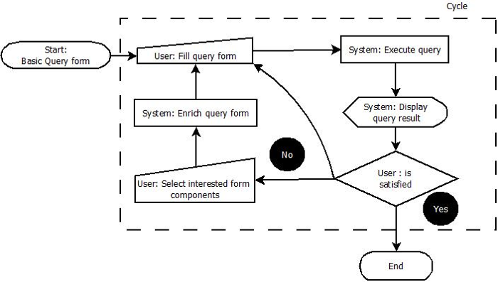

2.1.2 Software Requirements:
- JDK 1.6 with Java Server Page
- Open-source JavaScript library jQuery 1.4
- MySQL 5.1.39 as the database engine
- Apache Tomcat server

Language Used: PL-SQL, HTML, CSS, JavaScript, Java.

2.1.3 Hardware Requirements[Minimum]:

- Intel Core 2 Duo @2.83 GHz
- 80 GB HDD
- 1 GB RAM

2.2 Product Functions:

1. Keyword search with Query form generation

In the future it creates good deal of query forms. The user has to provide some keywords get the query forms from the large databases. The database that contains information in the form of rich text as data schemas and tuples works well. Again we can understand one difficulty with this user doesn’t have appropriate keywords to start.

2. Query Form Enrichment
1)DQF recommends a ranked list of query form components to the user.
2) The user selects the desired form components into the current query form.

3. Query execution
1) The user fills out the current query form and submit a query.
2) DQF executes the query and shows the results.
3) The user provides the feedback about the query results.

4. Customized Query Form
They provide visual interfaces for developers to create or customize query forms. The problem of those tools is that, they are provided for the professional developers who are familiar with their databases, not for end-users. If proposed a system which allows end-users to customize the existing query form at run time. However, an end-user may not be familiar with the database. If the database schema is very large, it is difficult for them to find appropriate database entities and attributes and to create desired query forms.

5. Database Query Recommendation
Recent studies introduce collaborative approaches to recommend database query components for database exploration. They treat SQL queries as items in the collaborative filtering approach, and recommend similar queries to related users.

3. SPECIFIC REQUIREMENTS

3.1 External Interface:

Input: The input will be in the form of keyword as the user preferences and his/her requirements. Also the keyword may be from ranked components as assisted by the system.

Output: Output will be the result of query as refined by the user.

3.2 Functional Requirements:

The system is proposed to have the following modules along with functional requirements.
- Query Form Enrichment
- Query Execution
- Customized Query Form
- Database Query Recommendation

3.3 Performance Requirements:

The system is proposed to have the following performance requirements

- The system should provide ranked components to assist user to make him/her decisions.
- The system should provide security to the user databases and assign roles to users.
- The user selected query must provide instantaneous results.

3.4 Software system attributes:

There are a number of attributes of software that can serve as requirements. It is important that required attributes be specified so that their achievement can be objectively verified.
    - Reliability

The query results will be accurate and will be totally based on user preferences and ranking algorithm.

    - Security

The database and its data retrieval will be available for authorized users only.

    - Availability

The system will be available as a web-application.

4 SOFTWARE DESIGN DOCUMENT
4.1 Structural Design:
- Class Diagram

4.2 Data Design:
a. Data Flow Diagram
Level -0

4.3 Behavioural Design:
- Sequence Diagram:
- Collaboration Diagram:

- Activity Diagram:

- State-chart Diagram

- Use-case Diagram:

- Sequence Diagram

4.5 Environment Design:
- Deployment Diagram:

5 TESTING, COSTING AND MEMBERS

5.1 Testing:
- Testing the query form interface with provided database
- Testing the results are accurate and based on the ranking algorithm.
5.2 Costing:
- Estimated hardware cost will be approx. 5000/-
5.3 Members:
- Maximum 5 members are required in this project.

6 REFERENCES
1. M. Jayapandian and H. V. Jagadish, Automating the design and construction of query forms, IEEE Trans. Knowl. Data Eng., vol. 21, no. 10, Oct. 2009, pp. 13891402.

2. E. Chu, A. Baid, X. Chai, A. Doan, and J. F. Naughton, Combining keyword search and forms for ad hoc querying of databases, in Proc. ACM SIGMOD, Providence, RI, USA, Jun. 2009, pp. 349 360.

3. M. Jayapandian and H. V. Jagadish, Automated creation of a forms-based database query interface, Proc. VLDB, vol. 1, no. 1, Aug. 2008, pp. 695709.

4. C. C. Aggarwal, J. Han, J.Wang, and P. S. Yu, A framework for clustering evolving data streams, in Proc. VLDB, Berlin, Germany, Sept. 2003, pp. 8192.

5. S. Agrawal, S. Chaudhuri, G. Das, and A. Gionis, Automated ranking of
database query results, in Proc. CIDR, 2003, pp. 888899.

